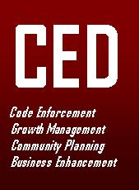
Department of
Community & Economic Development
Monthly Report

July 2009

Residential Planned Unit Development – Zoning Text Amendment
On behalf of the Township Zoning Commission, CED staff presented text amendment recommendations to Article 14 of the Goshen Township Zoning Resolution at a public hearing conducted by the Goshen Township Board of Trustees. The purpose of these amendments are to provide an improved set of development guidelines and regulations for both planned development – residential and planned development – mixed land use within Goshen Township. These text changes include new minimum building material standards, minimum lot size and front yard setback requirements, and more specific sidewalk and cul-de-sac design standards. The amendment also eliminated a complicated and unnecessary plan review points system.

This public hearing was the last in a series of three public hearings required by the Ohio Revised Code. The Goshen Township Board of Trustees will be asked to approve a motion adopting these zoning text amendments on August 12, 2009.

Clermont Transportation Connection Bus Stop Addition
CED staff continues to work with the management of the Clermont Transportation Connection (CTC) to improve the new fixed-route transit service between Goshen, Miami Township and the City of Milford. Efforts are currently underway to establish a new stop to serve elderly residents at O’Bannon Terrace on SR 132 near SR 28.

Traffic Signal at SR 28 and Charles Snider Road
Thanks to the advocacy efforts of Woodland Streams subdivision residents George and Barbara Jones, the installation of a full traffic signal and turn lanes at SR 28 and Charles Snider Drive is closer to a reality. ODOT has scheduled to have these safety improvements in place by the end of the year. It is this kind of unwavering community spirit that brings the attention and action necessary to address serious issues. The CED staff has and will continue to support such efforts.

CED Zoning Steps Up Municipal Court Mediation Efforts
In order to achieve greater compliance with both the Goshen Township Zoning Resolution and the Township’s Property Maintenance Code, zoning and property maintenance inspectors are actively working with the Clermont County Municipal Court’s Mediation Division. In the month of July, eight individuals, who have chosen to ignore the Township’s order to correct code violations, have been ordered to participate in the mediation process.

Municipal Court Action Results in Cleanup
As a result of a Municipal Court hearing, a Plum Street property comes into compliance with zoning and property maintenance standards. A forty-count indictment filed by the CED staff has resulted in the extensive property cleanup without the very expensive fine that could have been leveled against the property owner. Through a cooperative effort between the property owner and the Township’s Property Maintenance Code Officer, the list cleanup items was completed (see before and after photos below). Although not fined, Judge Thomas R. Herman did require that $400.00 in court costs be paid by the property owner.

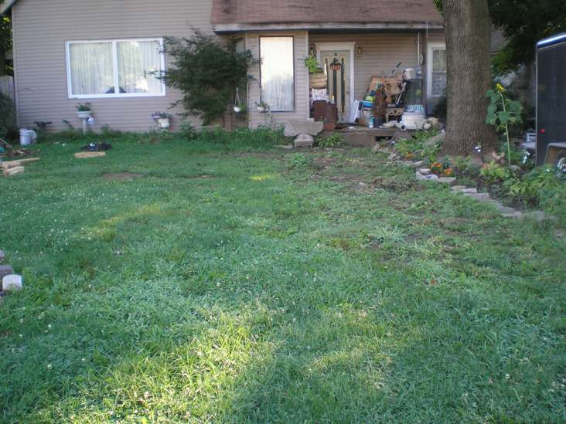
PROPERTY CLEANUP: BEFORE AND AFTER
